**Submission Instructions:**

Your submission for this project should be a Word document that includes the following screenshots, each labeled for the step that the screenshot represents:

1. Provide a screenshot to show that you have downloaded and extracted the Project 24_3_Kafka folder.

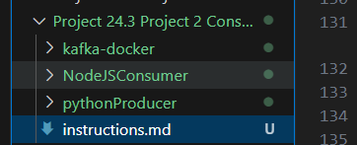

1. Provide a screenshot to show that you correctly configured your Docker Desktop and set your CPU and memory to a minimum of 6 GB.

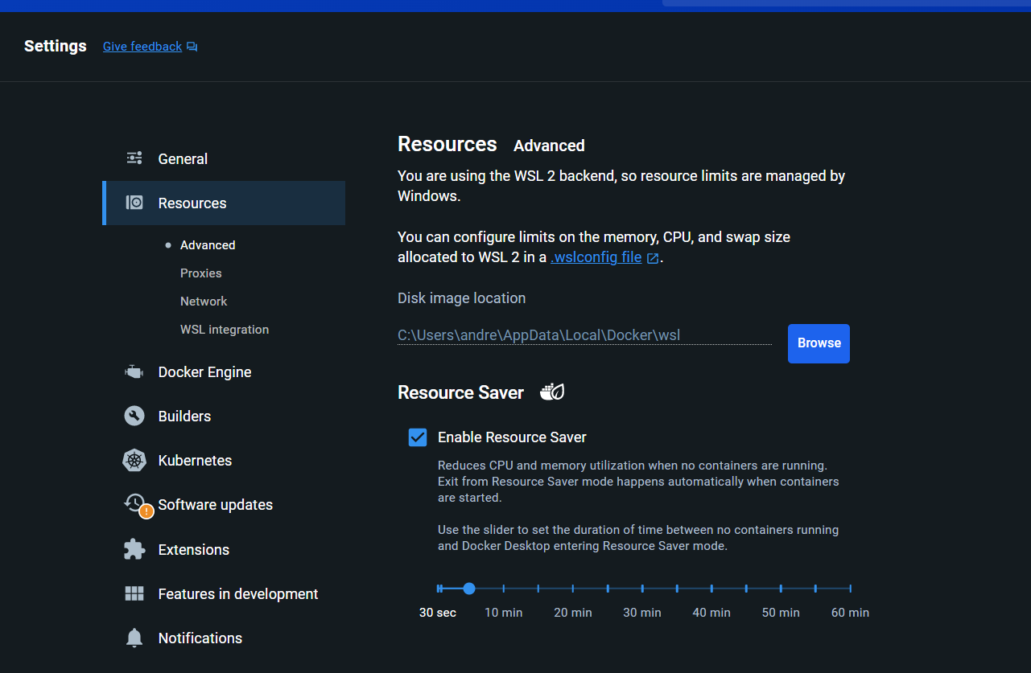

1. Provide a screenshot to show that you successfully executed the docker-compose command and created all of the required nine Kafka *container* components: zookeeper, broker, schema-registry, rest-proxy, connect, ksqlbd-server, ksql-datagen, ksqlbd-cli, and control-center.

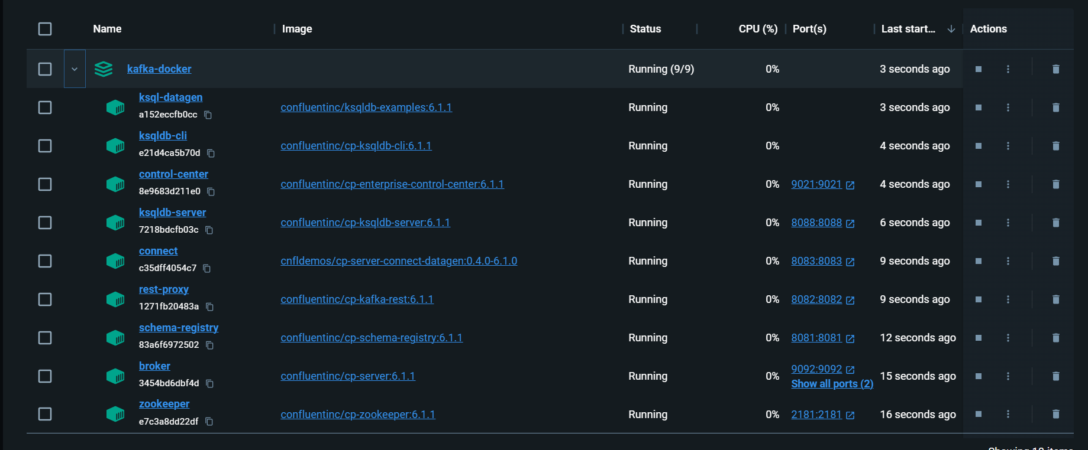

1. Provide a screenshot of the Confluent Control Center web interface to show that the *cluster* status is healthy.

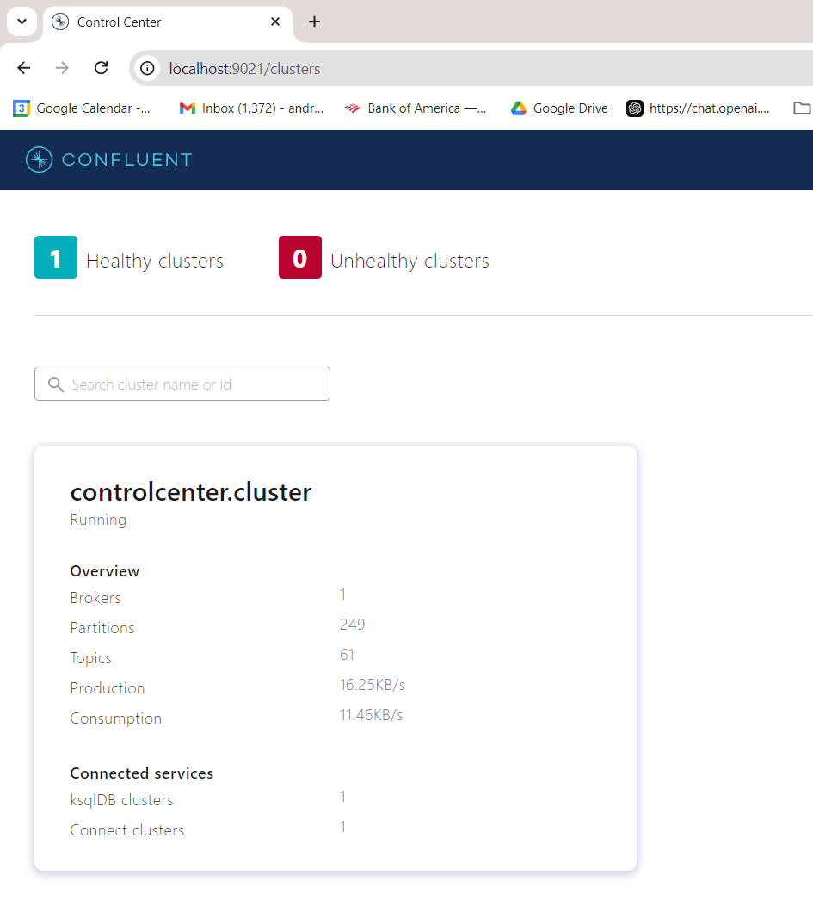

1. Provide a screenshot to show the existing default *topics* in the Confluent Control Center.

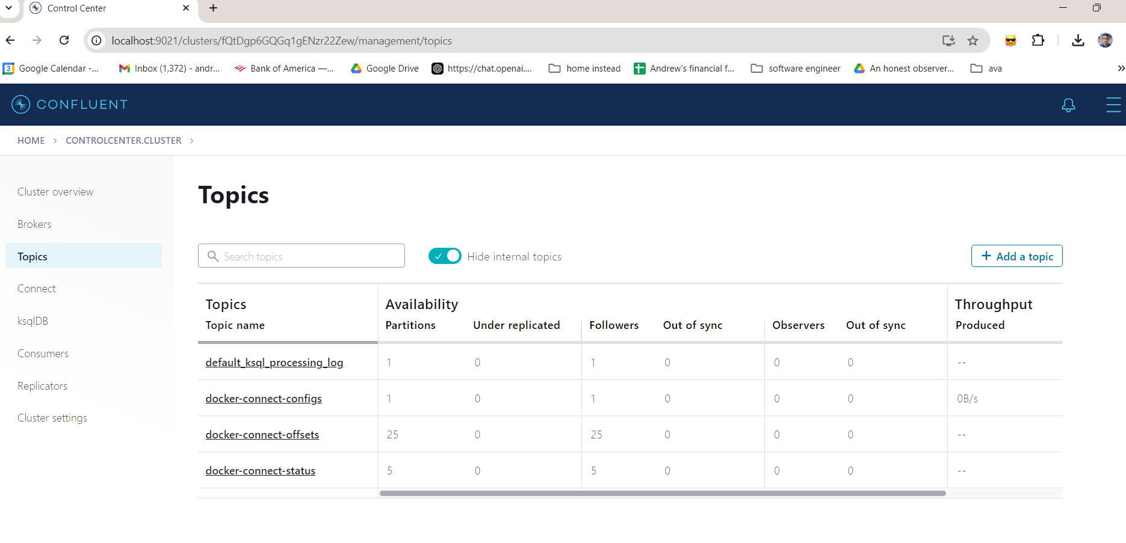

1. Provide a screenshot to show that you have successfully added the vehicle-coordinates *topic* with the correct settings.

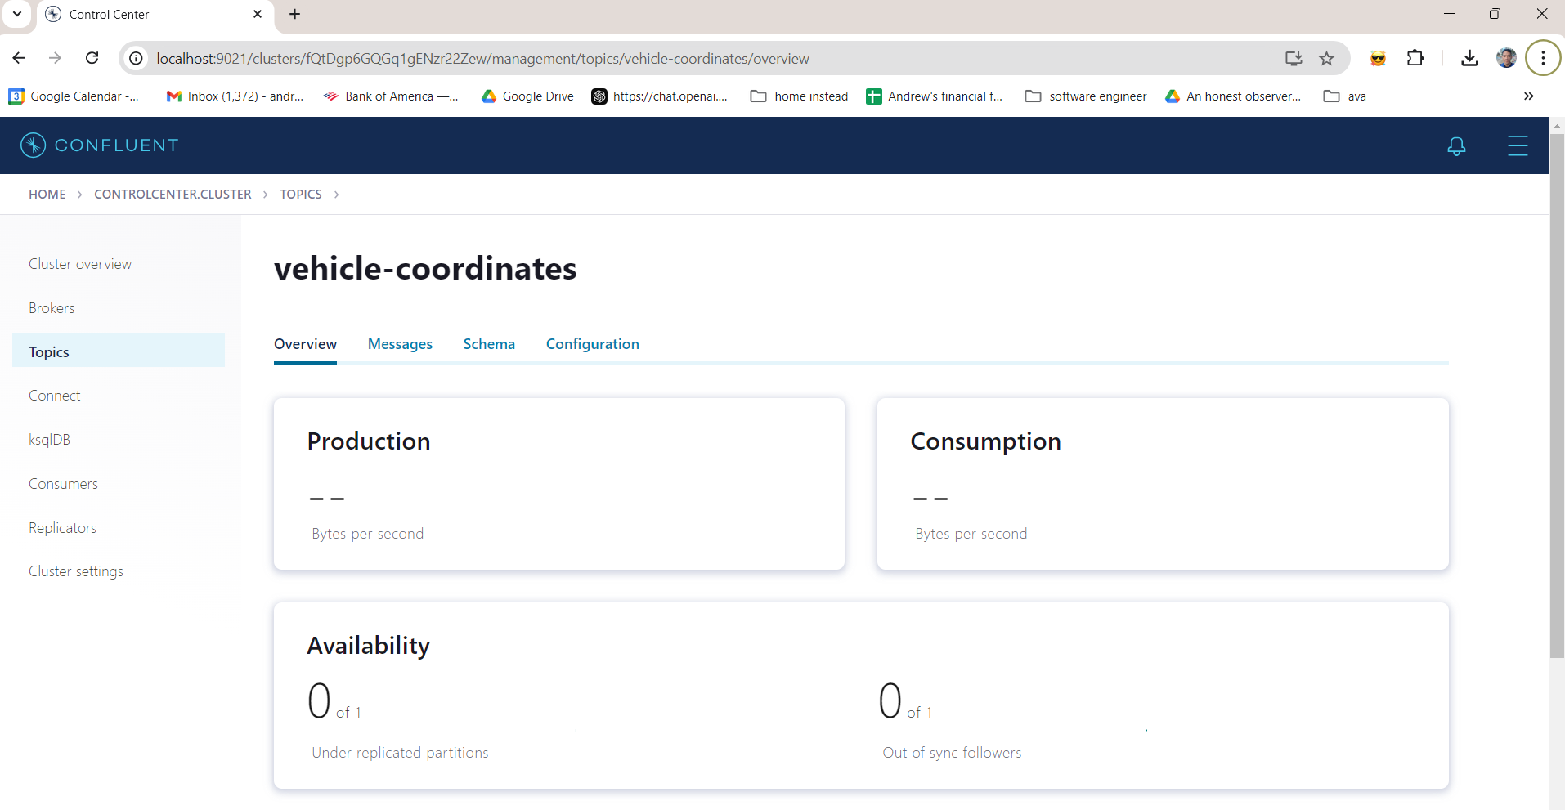

1. Provide a screenshot to show that you have successfully run the pip install kafka-python command.

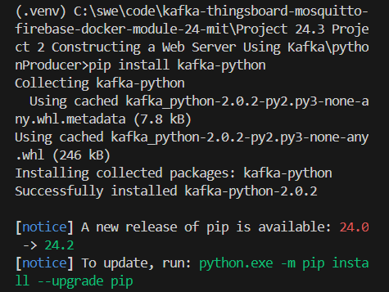

1. Provide a screenshot to show that you have successfully opened the PublishVehicleCoordinates.py file to create the template to define the *producer*.

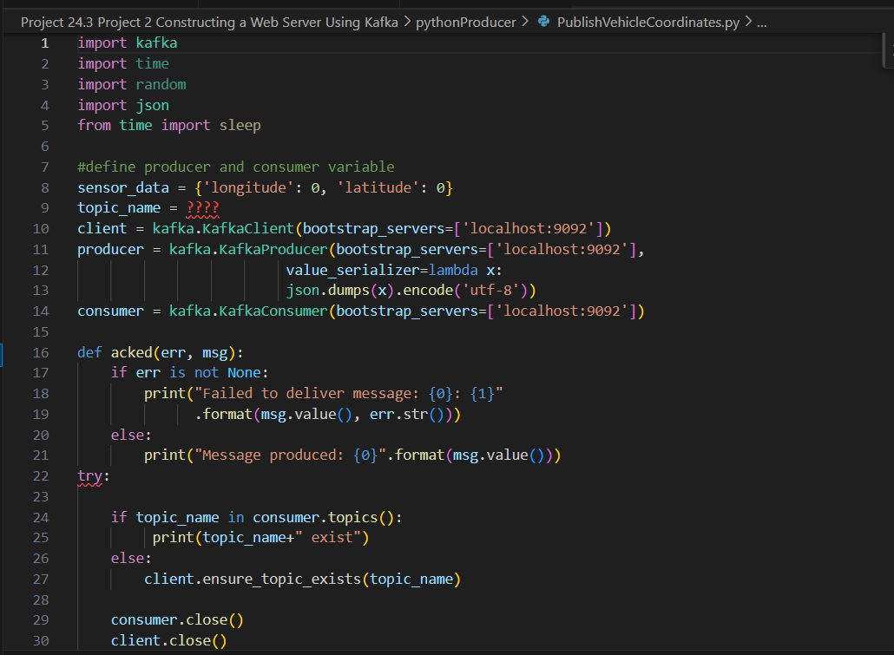

1. Provide a screenshot to show that you have correctly modified the code in the PublishVehicleCoordinates.py file.

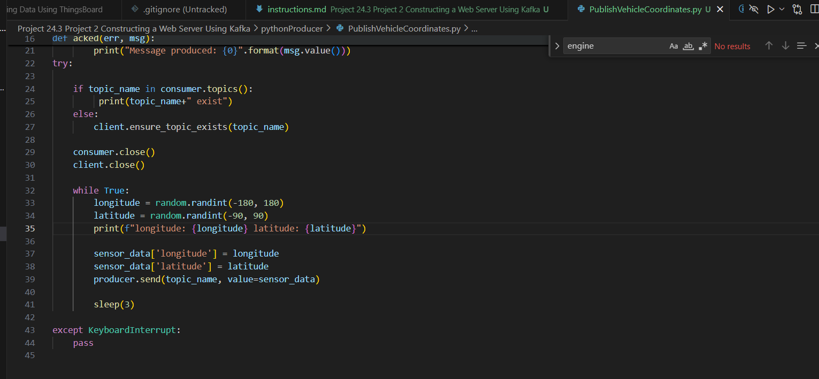

1. Provide a screenshot to show that you successfully ran the Python code from the command prompt and that the longitude and the latitude data is being produced.

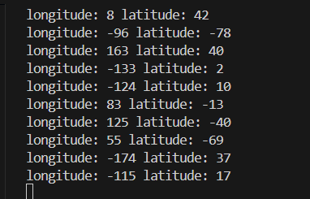

1. Provide a screenshot to show that you successfully ran the command to return the Node.js version number.

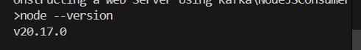

1. Provide a screenshot to show that you changed the server.js file to consume the vehicle-coordinates *topic* and changed the button value to display the Consume Vehicle Coordinates value.

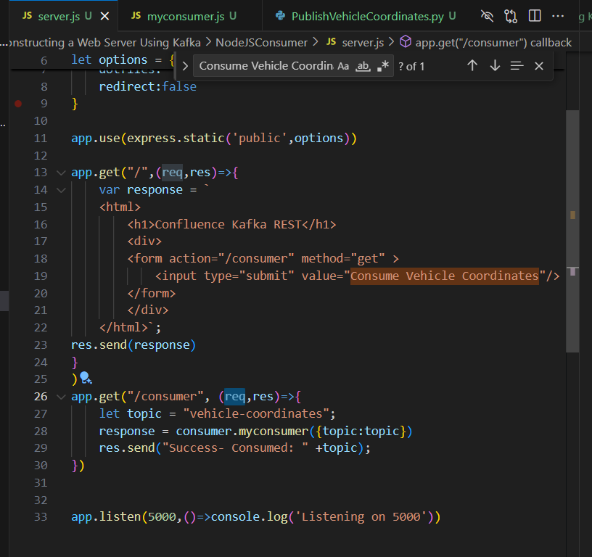

1. Provide a screenshot to show that you successfully installed the node-rdkafka *library*.

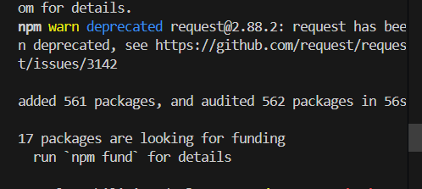

1. Provide a screenshot to show that you successfully ran the node server.js command and displayed the web page.

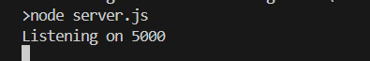

1. Provide a screenshot to show that the web page loaded correctly with a title of “Confluence Kafka REST” and a button labeled “Consume Vehicle Coordinates”.

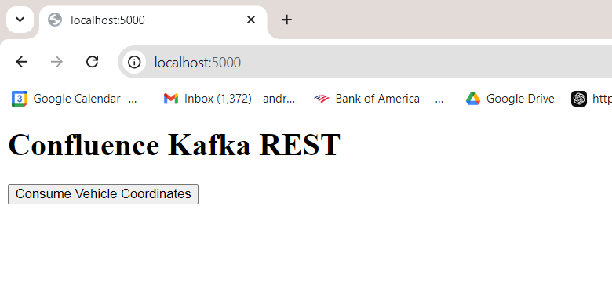

1. Provide a screenshot of the console to show the data being consumed without errors.

